**TripAdvisor E-Management**

### Acceptance Criteria & Solution

**1.Object Creation:**

1. **Go to Object Manager**
   * Click on the **Setup** icon (gear icon) in the top right corner.
   * In the Quick Find box, type **Object Manager** and select it.
2. **Create a New Custom Object**
   * In the Object Manager, click on **Create** > **Custom Object**.
3. **Define the Object’s Basic Information**
   * **Label:** Enter the name of the object (e.g., "Hotel").
   * **Plural Label:** Enter the plural form (e.g., "Hotels").
   * **Record Name:** This will be the primary field for the object (e.g., “Hotel Name”). Choose a **Data Type** (Text or Auto Number) based on your needs.
     + For the **Hotel** object, choose **Text**.
     + For **Food Option** and **Flight**, select **Auto Number** and set the format as specified (e.g., FO-{0000} for Food Option).
     + For **Customer**, choose **Text** for the Customer Name.
   * **Data Type for Auto Number Format:** Choose **Auto Number** for fields that need a unique identifier format.
4. **Set Optional Features for the Object**
   * **Allow Reports:** Enable this to allow data from this object to be included in reports.
   * **Allow Search:** Enable this to make the object searchable.
5. **Save the Object**
   * After entering the details and configuring settings, click **Save**.

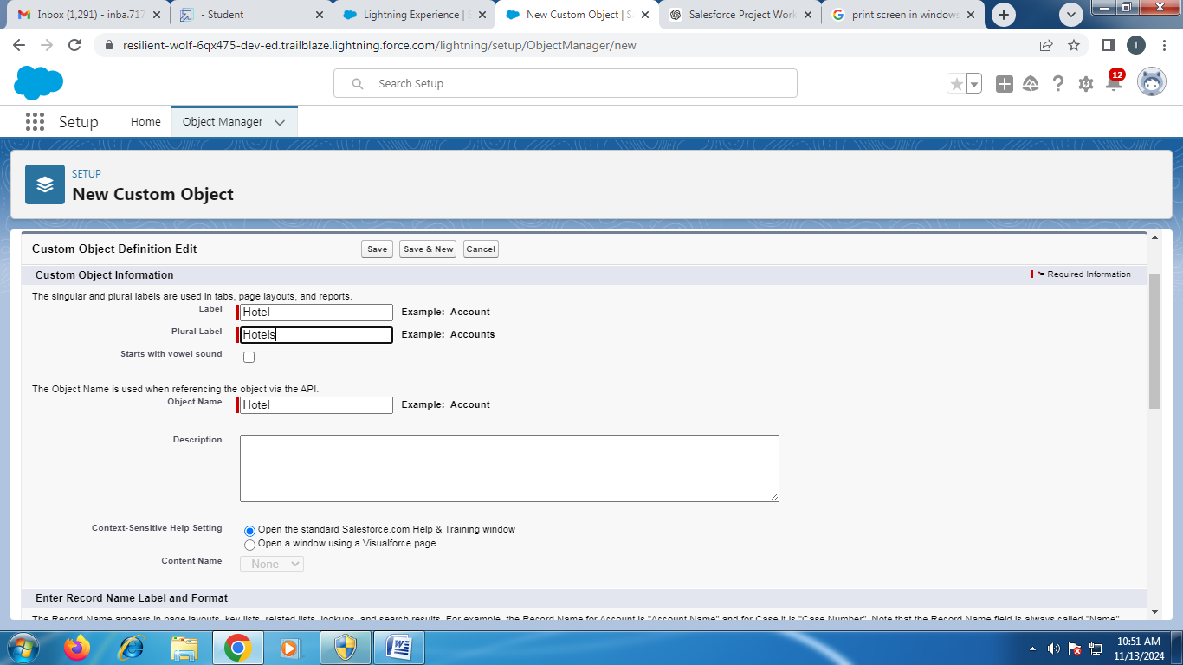

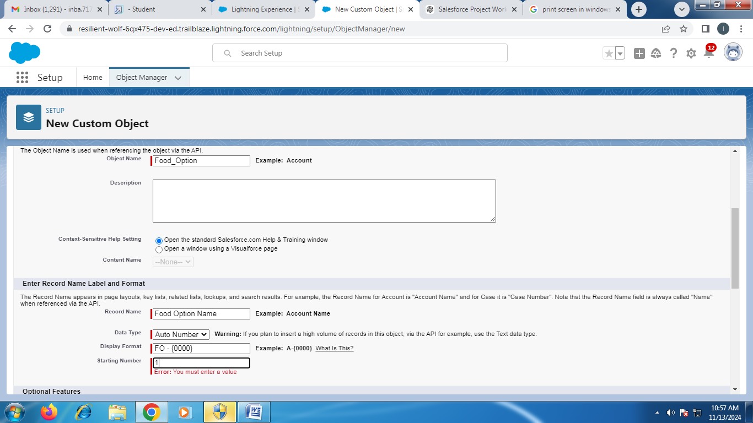

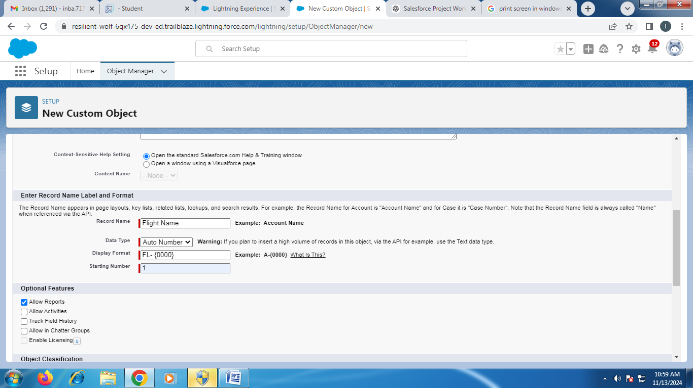

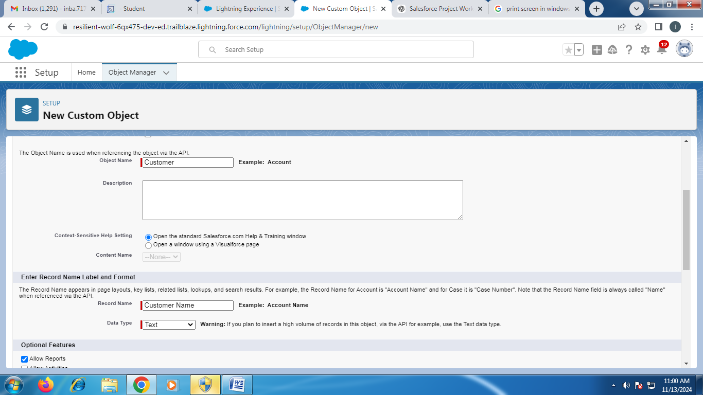

**Adding Fields to the Object**

1. **Go to the Object in Object Manager**
   * In **Object Manager**, find and select the object you just created (e.g., "Hotel").
2. **Add Fields**
   * Click on **Fields & Relationships** in the left sidebar.
   * Click **New** to add a new field.
3. **Select Field Type**
   * For each field, select the appropriate field type (e.g., **Text** for "Hotel Name" in the Hotel object).
   * Click **Next**.
4. **Enter Field Details**
   * **Field Label:** Enter the name (e.g., "Hotel Name" for Hotel).
   * **Field Name:** This will automatically be populated.
   * Complete other necessary field settings as per your requirements.
   * Click **Next** to continue.
5. **Set Field-Level Security**
   * Decide which profiles should have access to view or edit this field.
   * Click **Next**.
6. **Add the Field to the Layout**
   * Choose whether to add the field to the default layout.
   * Click **Save**.

Repeat these steps to create all the required fields for each object (e.g., Hotel, Food Option, Flight, Customer).

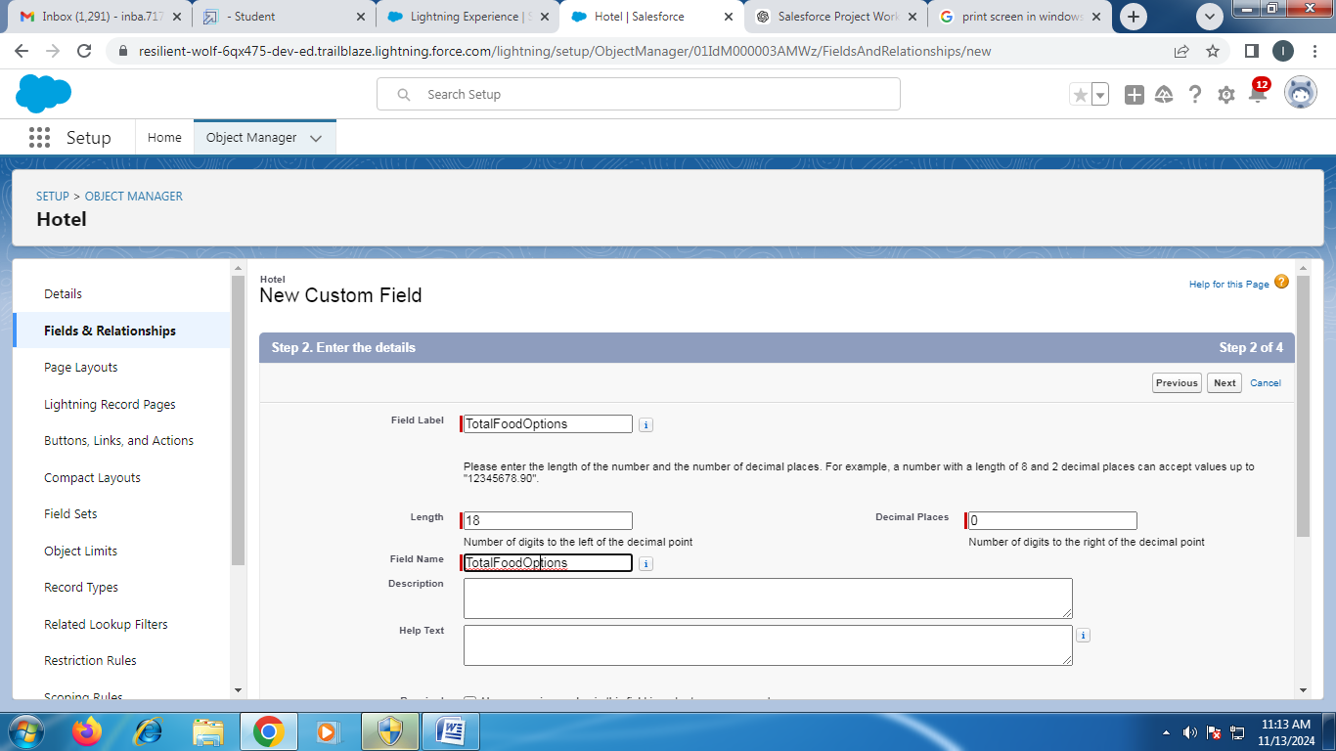

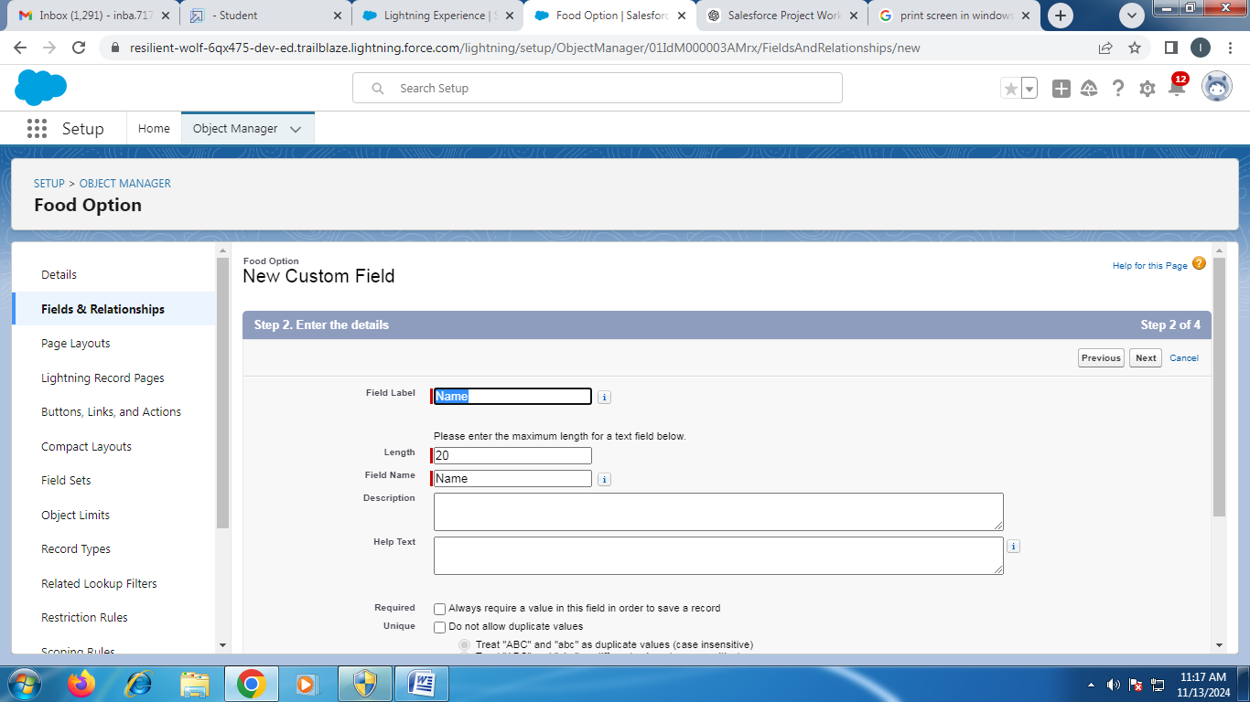

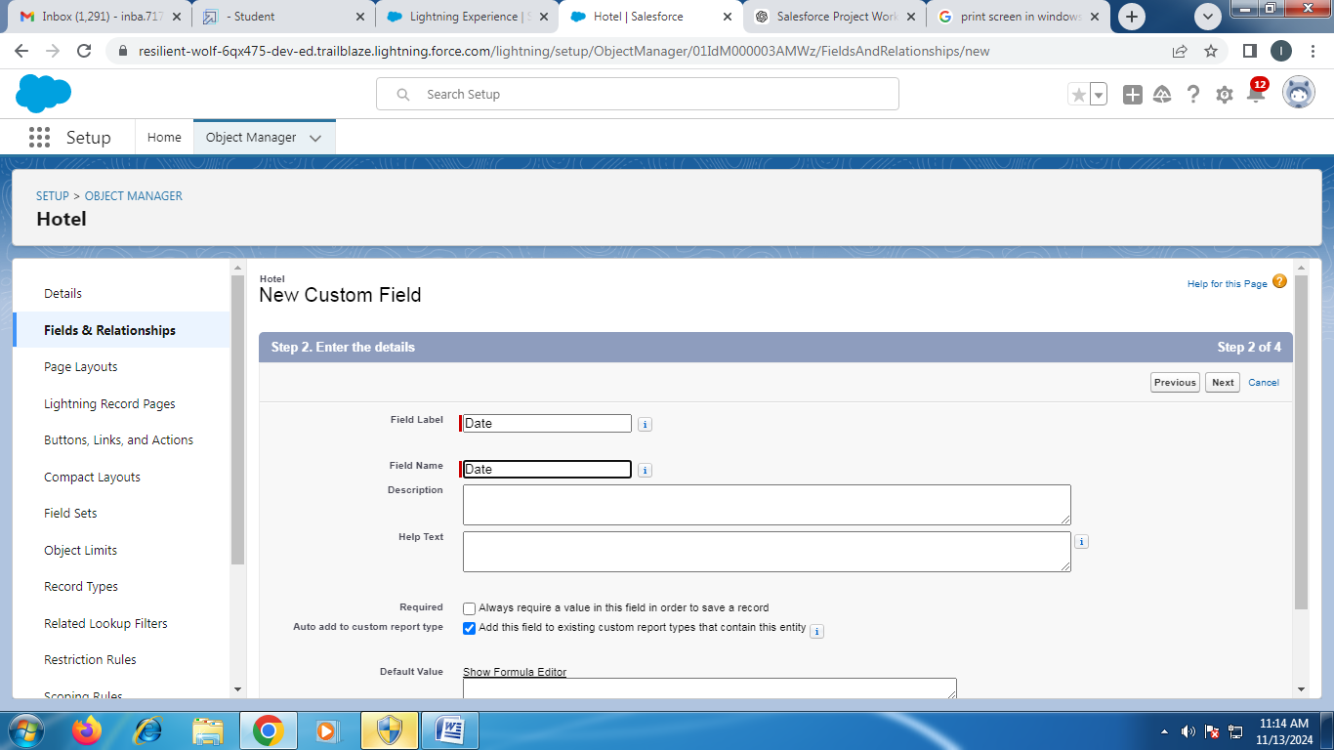

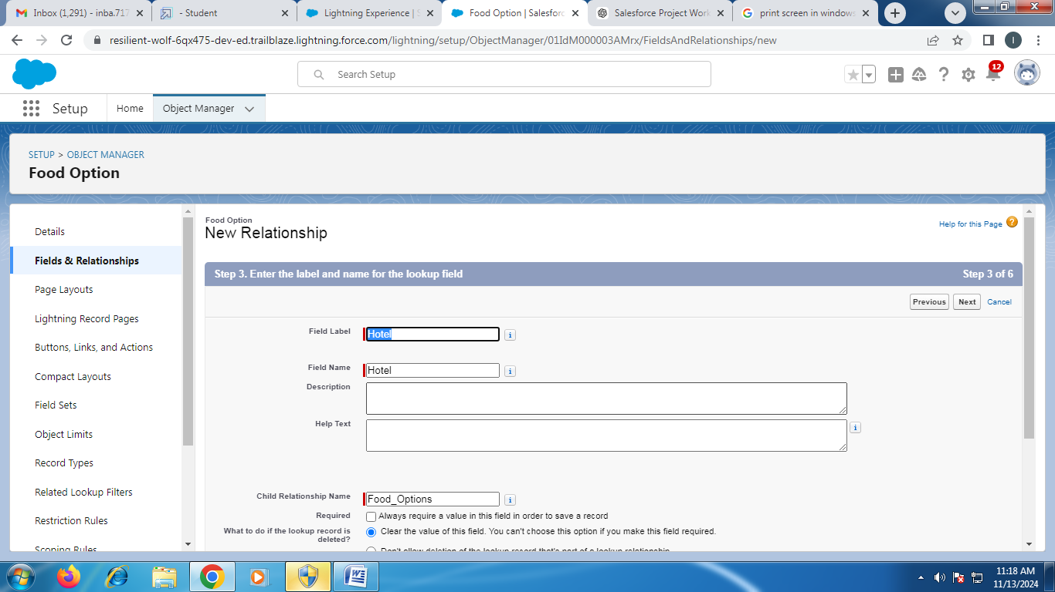

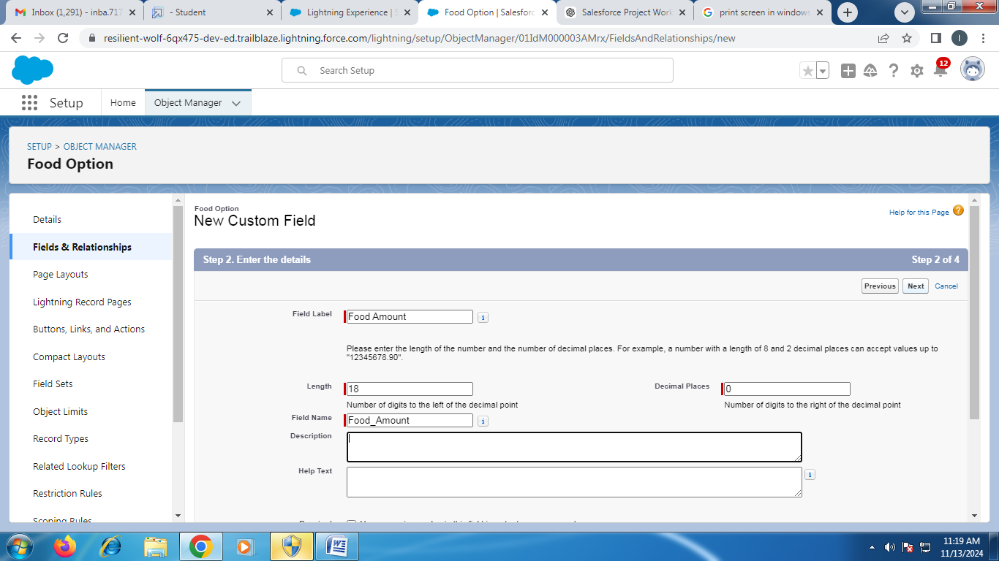

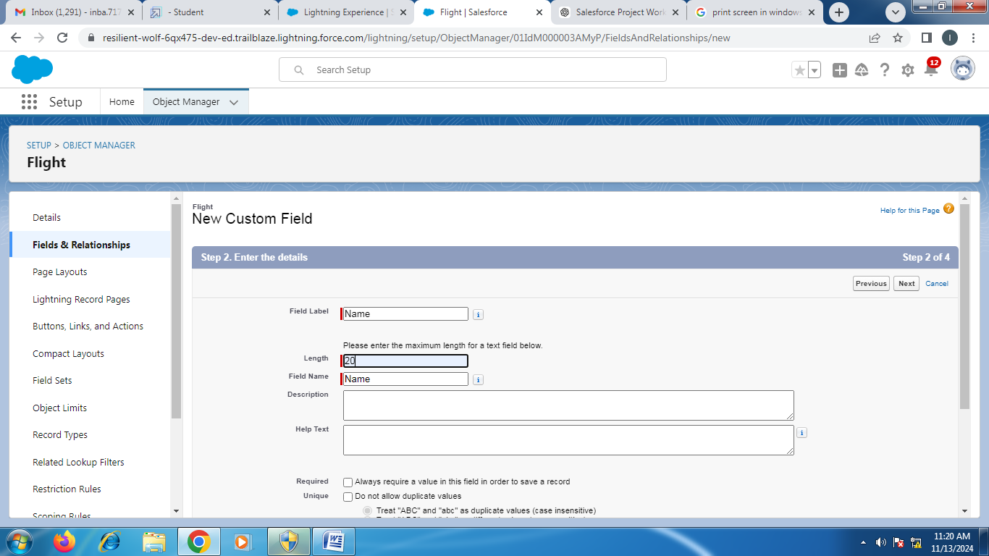

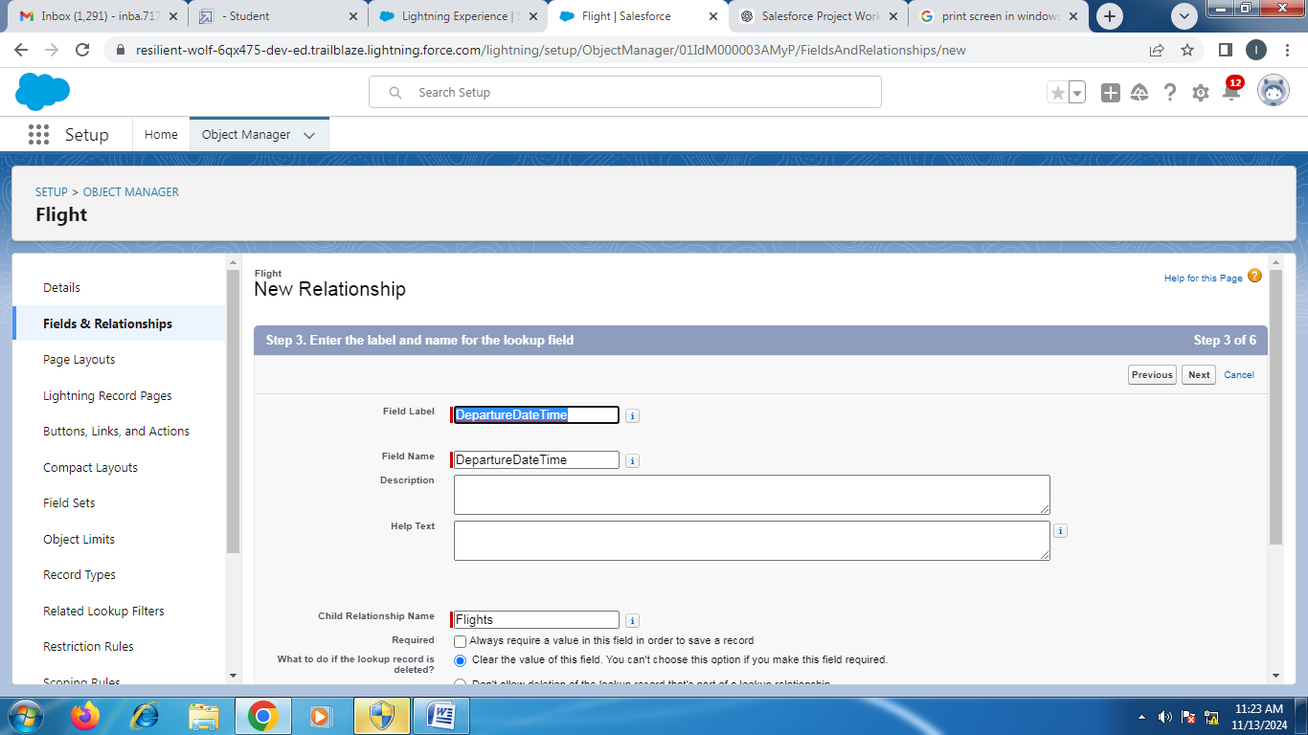

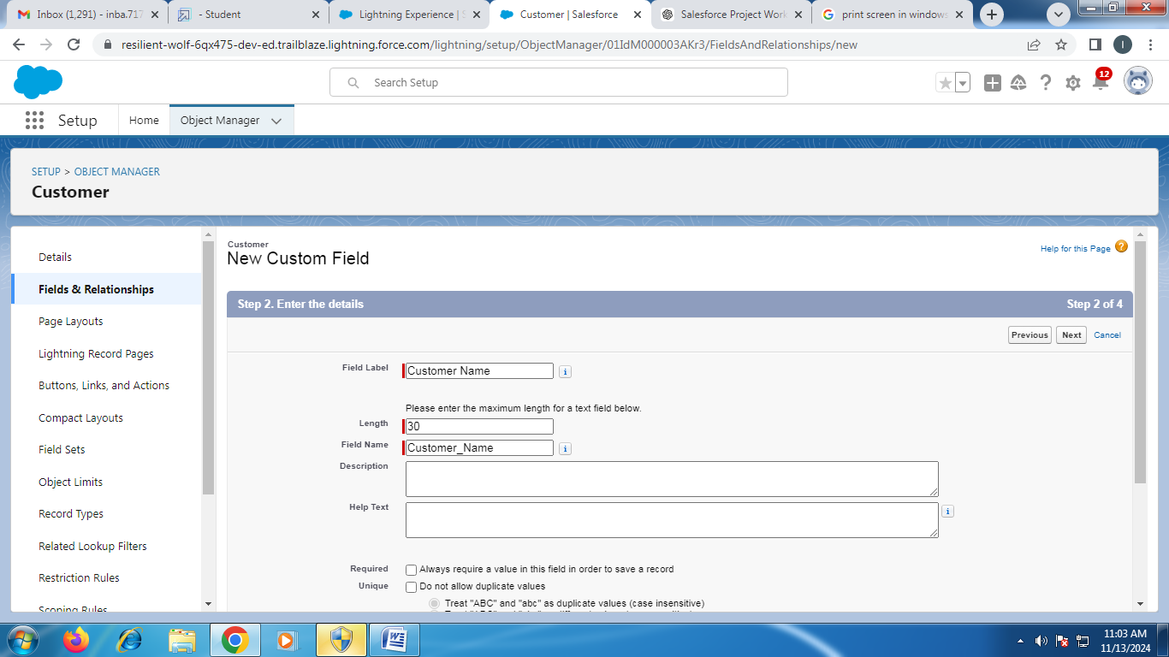

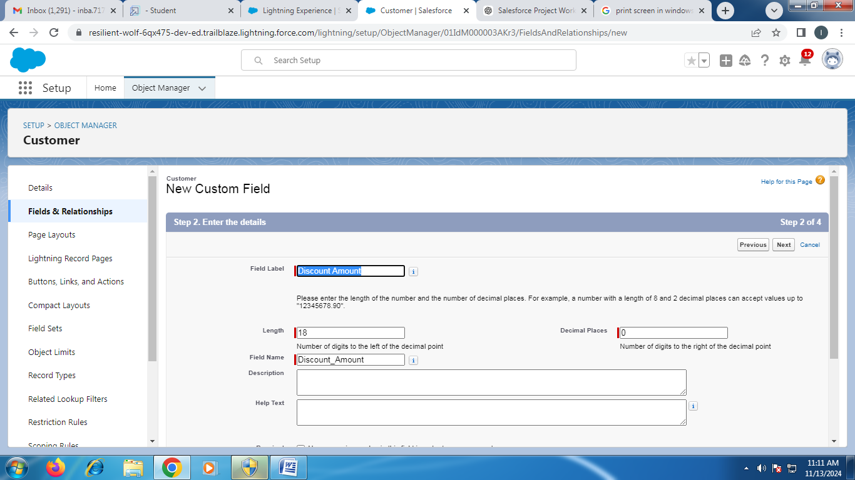

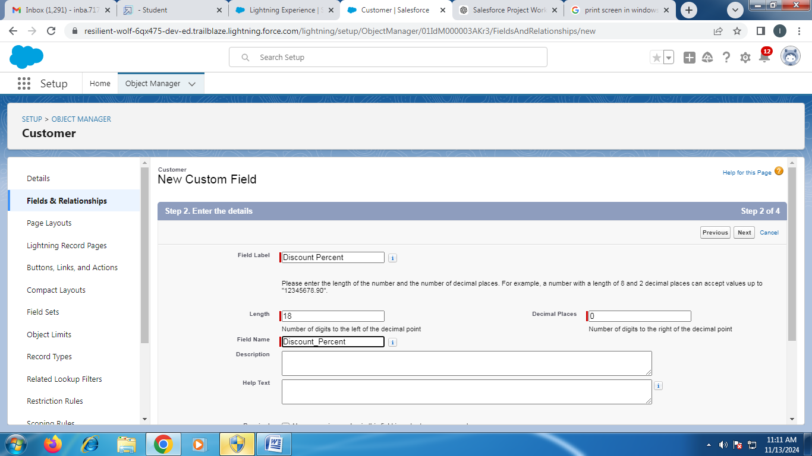

### Creating Flow

**s**